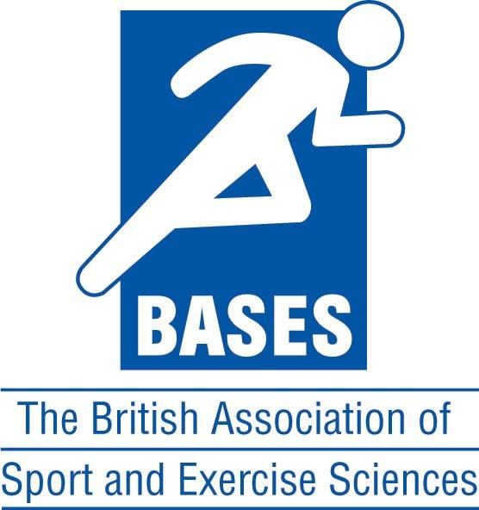
Sport & Exercise Psychology Accreditation Route

SEPAR Candidate annual review form

To ensure that the SEPAR Advisory Group (SEPAR AG) maintains its quality assurance and standards it will be subjected to a full review for currency on a five-year cycle. To facilitate the review, SEPAR candidates are invited to complete an annual feedback report to provide information to the SEPAR AG relating to, for example: development of contemporary topics; administration for the SEPAR; development and training opportunities; review processes; and, supervision.

When completing your responses, please give consideration to how your SEPAR experience has met your initial expectations and to whether any amendments to the process are required.

Candidate name:

Date of entry to SEPAR:

- Please provide your thoughts to the topics that require competence to be evidenced and to whether any additional topic areas warrant inclusion.

- Please comment to the administrative processes that you have experienced whilst on the SEPAR.

- Please comment on the development and training opportunities that you have completed and the extent to which they have been of benefit. If there are any additional training and development requirements that are currently not available, please identify them here.

- Please comment to your experiences of the review processes for your SEPAR.

- If you have any comments regarding supervision, please indicate them here.

- Have you experienced any issues with regard to equality, diversity and inclusion?
(Please be assured that your responses will be treated in the strictest confidence and responded to as a matter of priority).

- Any additional comments that you would like the SEPAR AG to be made aware of.

